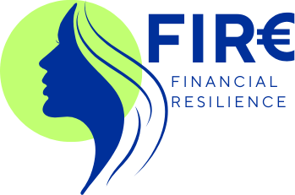 | 

MULTIPLIER EVENT
Multiplier event kit

A hybrid half-day event (in person and online) for about 30 participants per event, presenting the FIRE results to local stakeholders and communities: adult educators, social workers, service providers, NGOs, education organisations, local authorities and women's associations. Informamentis Europa holds one in Italy and EDUMANSHA one in Portugal, using this methodology from Never Give Up Förderverein. The aim of each event is to show the materials in action, collect feedback, and invite organisations to use the results and join the online support network.

 |  | 

Funded by the European Union. Views and opinions expressed are however those of the author(s) only and do not necessarily reflect those of the European Union or the Italian National Agency Erasmus+ INDIRE. Neither the European Union nor the granting authority can be held responsible for them. Project 2025-1-IT02-KA210-ADU-000354693

Agenda
Min | Item
15 | Arrival, registration (in person and online) and welcome
20 | Economic abuse: why it matters, and Directive (EU) 2024/1385
20 | The FIRE project and its results: modules, Training Pills, guidelines, tools and network
30 | Hands-on demonstration: one Training Pill and one interactive tool, with online participants joining in
20 | Voices from the pilots: educators share what they learned (and women, if they wish and with consent)
15 | Break and networking
30 | Discussion: how can your organisation use FIRE? Small groups in the room and online breakout rooms
10 | How to join the online support network and access the materials
10 | Feedback form and closing

Invitation
You are invited to the FIRE multiplier event, '[title]', on [date] at [time], at [venue] and online. FIRE (Financial Resilience) is an Erasmus+ project on economic abuse against women. At this free event you see the FIRE training modules, Training Pills, guidelines for educators and interactive tools in action, hear from educators who used them in pilot sessions, and discuss how your organisation can use them in its work with women. The event is for adult educators, social workers, service providers, NGOs, education organisations and local authorities. Register by [date] at [link or email], saying whether you join in person or online.

Feedback form
1. Which type of organisation do you represent?

2. Did you take part in person or online?

3. How useful was the event for your work? (1 to 5)

4. Which FIRE result is most relevant to you?

5. How likely is your organisation to use the FIRE materials? (1 to 5)

6. How might you use them?

7. Would you like to join the online support network or receive the newsletter?

8. Any other comments or suggestions?

Event report

Partner, title, date, venue and online platform

Agenda as delivered

Participants: number in person and online, types of organisation (attendance list attached)

Summary of presentations and demonstrations

Main points from the discussion

Feedback form results

Organisations interested in using the results or joining the network

Photos (with consent) and media coverage

Lessons learned

Sign-in sheet
Name | Organisation | Email | Signature

